Refresher: hackathon plan and team split
Oct 19, 2026 · @Kirill
Table of Contents
Refresher: hackathon plan and team split 1
What we build 1
How it scores against the judging criteria 1
Prior art and our delta 2
Architecture 4
Ingestion pipeline 5
Knowledge model and scoring 7
Layer 1 · Lexical: what was captured 7
Layer 2 · Subject: what it says 8
Layer 3 · Domain: who says it 8
Edges inside and across layers 8
Many claims per item, and multi-layered articles 9
Graph structure 9
Why Neo4j, not SQLite 9
The graph module and who calls it 10
Ingest vs. hourly review 11
Knowledge management 11
The life of a claim 12
Rules 12
Retrieval and the refresher 12
Entry points 13
Refresher and /ask: what each is for 13
The refresher, step by step 14
Tools 15
/ask and MCP 15
How we know it works 15
Retrieval plan 16
Seed corpus and test fixtures 16
Verified platform facts 17
Team split 19
Timeline 21
Demo script and submission checklist 21
Submission 22
Risks and fallbacks 23

What we build
Refresher is an open-source knowledge engine that collects notes from everywhere, keeps the raw, builds structure above it, and hands you a refresher on a topic the moment you need it. Entry for the Nebius x NVIDIA Global AI Hackathon, Personal AI track. Submission closes Friday 30 October 2026, 10:00 PT, so we have 15 days. Commercial analog: Mem. Ours runs on Nemotron via Nebius Token Factory, with the data in your own Obsidian vault.
Inputs: Telegram forwards and channels, newsletters, saved articles, LinkedIn shares, YouTube transcripts, voice thoughts. Every input is stored once, immutable, as a raw item.
Above the raw, the engine extracts ideas and claims, links them into threads, identifies the people behind channels, newsletters and articles, and decides what is a repost, what superseded what, and what is still current.
On demand, for a topic, it returns a refresher:
- Ideas I already hold on this, each with a string back to the threads and raw items behind it
- What is current, what is foundational, what has decayed or been superseded
- Noise collapsed: twelve channels reposting one announcement count as one
- The experts graph: who talks about this, their domains, how much to trust them and why
- A dig-deeper pack: a markdown handoff and an MCP endpoint so Claude can pull the strings itself

How it scores against the judging criteria
The four criteria are weighted equally. Stage one is pass/fail on fit to the track and real use of Token Factory plus an NVIDIA model.
Criterion | What judges look for | What we show
Technological implementation | How well built; effective use of Token Factory and Nemotron | Nano for every fast call, Super for synthesis and adjudication, Serverless Endpoint and Job, typed edges with stored rationale, unit-tested scoring
Design | A complete product, not a proof of concept | Telegram in, Obsidian vault out, refresher on demand, trust and freshness visible in every note, handoff to Claude
Potential impact | Credible case for a real audience | Our own daily problem: drowning in channels and newsletters; eval table on a seed corpus with planted reposts and supersessions
Quality of the idea | Non-obvious use of the models; understanding of the problem space | Triage of an uncurated stream, learned trust per person, provenance strings, half-life per claim; side-by-side with llm-wiki-agent in the README
Best Use of Tavily (bonus, $3,000) | Functional runtime Tavily call | People enrichment and LinkedIn post extraction call Tavily at runtime, logged
Source: official rules, read 15 October 2026.

Prior art and our delta
Nobody combines stream triage, people with learned trust, provenance strings and on-demand refreshers. Each piece exists somewhere, checked 15 October 2026.
Project | What it already solves | What we do with it
Karpathy LLM Wiki and llm-wiki-agent (MIT) | raw/ to wiki/ with index.md and log.md; ingest, query, lint; lint flags contradictions and stale claims | Adopt the vault layout as our human-readable layer. It assumes curated inputs and a frontier coding agent per source; no runtime, messengers, people, trust or time.
Graphiti / Zep (Apache-2.0) | Bi-temporal edges (valid_at, invalid_at, created_at, expired_at), invalidate instead of delete | Borrow the field names and semantics, not the library: it warns that small models break its structured output, no trust or decay.
datarootsio/knowledgebase_guardian | Contradiction gate at insert: retrieve similar, ask the LLM | Same step as our relation check; we store the verdict as a typed edge with rationale instead of rejecting the document.
fenixvd/obsidian-telegram-bot, TelegramObsidian, tg2obsidian | Telegram forward to markdown note with frontmatter, Docker | Capture is commodity. Write a thin aiogram bot that also replies with the filing verdict.
Mem (commercial) | Note capture, AI organisation, knowledge management | Closest product. Ours is open source, on open models, data in your vault.
Cognee, Mem0, Letta | Agent memory layers; Cognee has forget as delete | Related work in the README; no decay, trust or temporal state.
Contradiction to Consensus, Zep paper | Per-source confidence and dispersion; temporal knowledge graph for memory | Cite in ARCHITECTURE.md; our trust update is a simplified per-source confidence.
The honest framing for the README: the wiki layout, contradiction flagging and bi-temporal edges are borrowed and credited. The contribution is triage of an uncurated stream, an experts graph with trust learned from what later got confirmed or superseded, strings from idea to raw, and the refresher with handoff.

Architecture
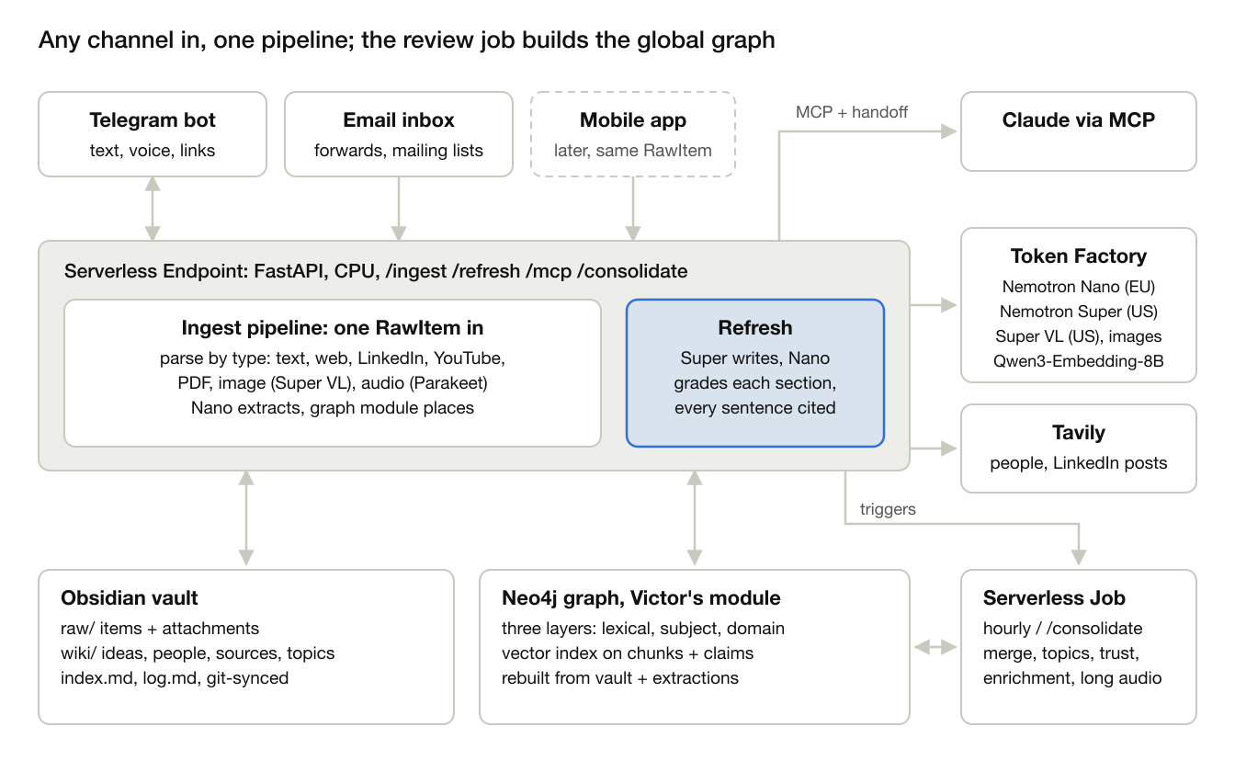
architecture · any channel, one ingest pipeline, one review job, vault + index
Telegram and email feed the endpoint today and a mobile app can later; every channel produces one RawItem. Ingest writes the vault and the index; people enrichment runs in the review job. The refresher reads them on demand through structured tools rather than raw search, and Claude pulls strings through the MCP endpoint. The hourly review job merges duplicate people and ideas, reruns relation checks, clusters topics, runs Tavily enrichment and recomputes trust. Freshness itself is computed at query time.

Ingestion pipeline
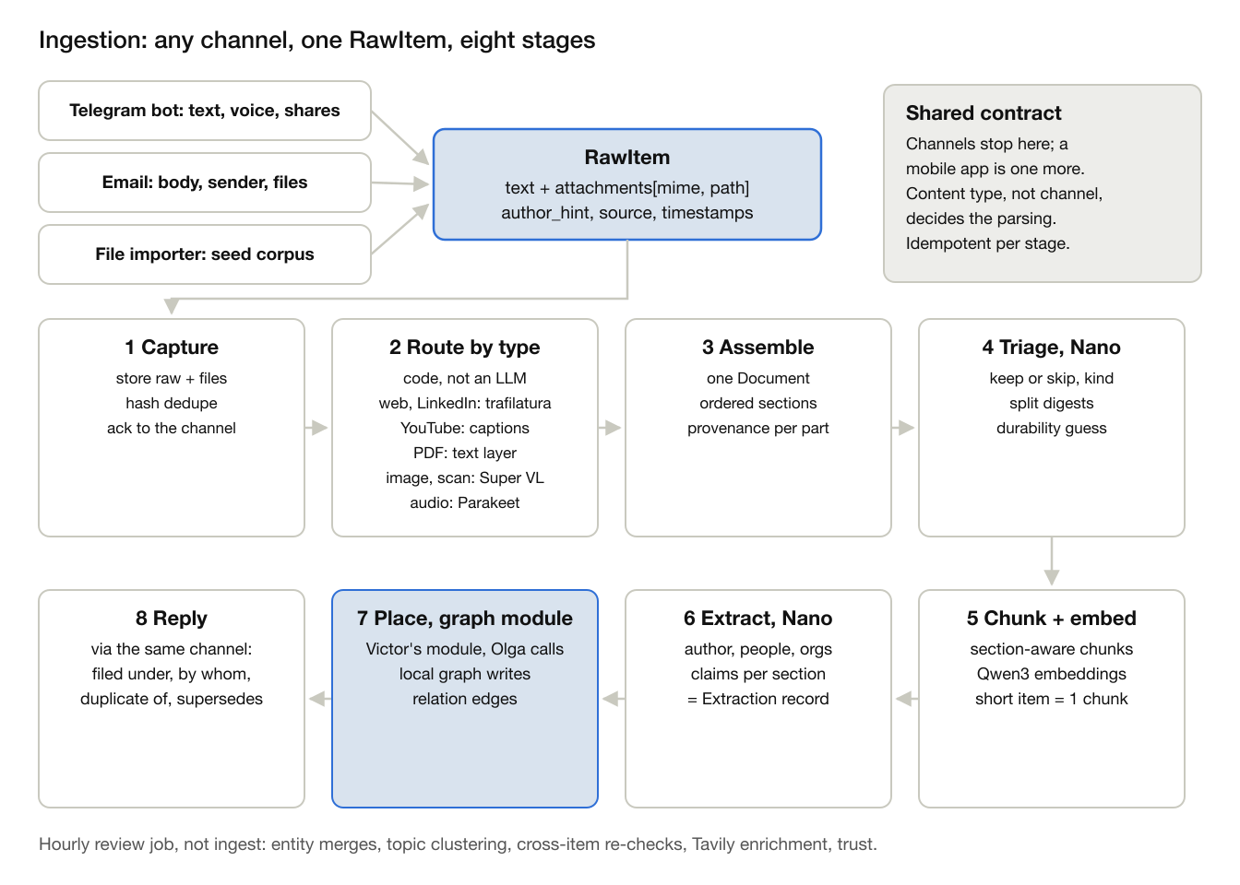
ingestion · any channel, one RawItem, eight stages
One interface. A channel adapter does only channel work: who sent it, who wrote it, which source, which files. The Telegram bot reads forward_origin, text, voice notes, files and links; email reads the body, the original sender of a forward, List-Id and attachments; a mobile app later posts the same RawItem to /ingest. Content types are not tied to a channel: a voice note, a YouTube link or a PDF is parsed the same way whichever channel brought it. A file importer is one more channel: it brings the seed corpus in through the same door.
1. Capture. Store the raw item and its files in raw/, dedupe by content hash and message id, and ack to the channel. The webhook returns here; stages 2 to 8 run in a background task.
2. Route by type. Plain code on MIME type and URL pattern, not a model.
- Text and HTML: trafilatura.
- A link in the message: fetch the article.
- LinkedIn link: public articles (linkedin.com/pulse) carry schema.org Article JSON-LD with the author's name and profile URL, the publish date and the headline; the body comes from trafilatura. Posts (/posts/, /feed/update/) usually redirect to the login wall, so they go to Tavily extract, and if that fails the bot asks for the post text or a screenshot (Super VL reads it). We never log in to LinkedIn with a scraper account.
- PDF: PyMuPDF text layer per page. Images, and PDF pages without a text layer: Nemotron Super VL for OCR and a caption. Audio (voice notes): Parakeet transcription.
- YouTube link: the published captions, or the audio through Parakeet when there are none.
3. Assemble. Gather every part back into one Document: ordered sections, each with provenance (email body, attachment page 3, image 2). An email with three attachments is one item, not four. A linked article, LinkedIn share or YouTube video becomes its own child item with its own author and source (the writer, the LinkedIn profile, the YouTube channel), linked to the forward that shared it. A voice note is the sender's own thought: author is the user.
4. Triage, Nano. The one decision model before extraction: keep or skip, kind (post, article, newsletter digest, announcement), durability guess, and whether to split a digest of ten stories into ten items.
5. Chunk and embed. Section-aware chunks of a few hundred tokens with Qwen3 embeddings, for retrieval of passages. A short Telegram post is one chunk.
6. Extract, Nano. Author (taken from metadata when the page has it, as on LinkedIn, so Nano only fills gaps), mentioned people and organisations, links and atomic claims, each claim pointing to its section. Nano's 262K context takes most documents whole; longer ones go per section. The output is the Extraction record, stored next to the raw item.
7. Place, graph module. One call, graph.apply(extraction), into Victor's module: it writes the Item, Sections, Chunks, Claims, Person and Source stubs, attaches each claim to an idea or opens a provisional one, runs the relation check against near neighbours and returns the placement for the reply.
8. Reply through the channel that brought the item: filed under, by whom, duplicate of, supersedes.
Decision models in between. Routing is deterministic; a router model adds cost and failure modes for a choice the MIME type already makes. Models decide only content questions: Super VL reads pixels, Parakeet turns speech into text, Nano triages and extracts. Every stage writes its status on the item, so a crash resumes from the last stage and a re-run is safe. Large PDFs and audio longer than a few minutes go to the Serverless Job instead of the endpoint.
Graph builder in two halves. Ingest builds the local graph for one item at step 7, which is what makes the reply possible. The hourly review job builds the global graph: entity merges, topic clustering, re-checks across items, enrichment and trust. Details in Graph structure and Ingest vs. hourly review.

Knowledge model and scoring
Three layers, following the three-graph architecture from the Amazon presentation Olga photographed. Each layer answers one question and changes at its own pace: the lexical layer never changes, the subject layer is revised by the review job, the domain layer grows with enrichment.
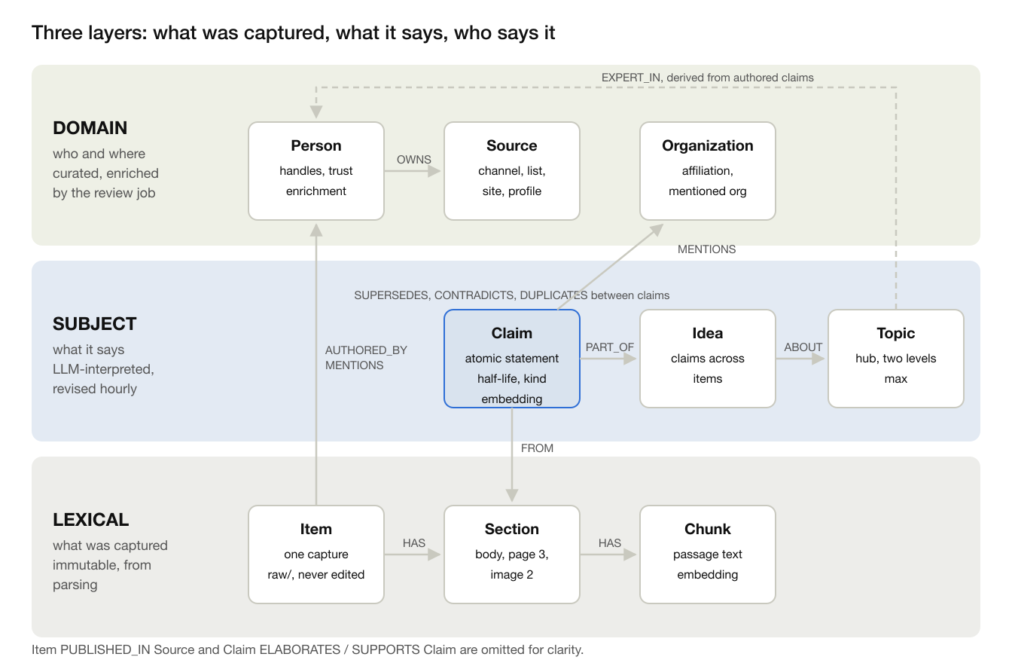
layers · lexical, subject, domain

Layer 1 · Lexical: what was captured
Immutable. Built by parsing, before any model interprets anything. It is the anchor for provenance: every claim points back to a section here.
Node | Holds | Created by | Lives in
Item | channel, source, captured_at, published_at, url, kind (post, article, video, voice, thought), raw text, attachments | Capture, stage 1 | raw/ and the graph
Section | one part of the item in order: email body, attachment page, image, transcript, with its provenance | Assemble, stage 3 | graph
Chunk | a passage of a few hundred tokens and its embedding | Chunk + embed, stage 5 | graph, vector index

Layer 2 · Subject: what it says
LLM-interpreted. Ingest adds to it; the hourly review revises it. Claims are the unit of decay, not items.
Node | Holds | Created by | Lives in
Claim | kind (fact, announcement, opinion, how-to, principle), durability class, half-life days, confidence, model version, valid_at, invalid_at, created_at, expired_at, superseded_by, embedding | Extract, stage 6 | graph, mirrored in frontmatter
Idea | title, summary, first_seen, last_touched: claims that say the same thing or form one thread across items | Graph module at ingest (provisional), review (merge, split) | graph, wiki/ideas/
Topic | title, parent topic (two levels at most), latest refresher | Review job only | graph, wiki/topics/

Layer 3 · Domain: who says it
The real-world entities behind the content. Ingest creates stubs; the review job merges and enriches them.
Node | Holds | Created by | Lives in
Person | name, handles (Telegram, email, LinkedIn URL), role, affiliation, domains, trust, trust rationale, profile sources, enrichment_status | Ingest (stub), review (enrich, merge) | graph, wiki/people/
Source | channel, newsletter or mailing list, site, LinkedIn profile; owner, reliability | Ingest | graph, wiki/sources/
Organization | name, kind, site | Extract (mentions), enrichment (affiliations) | graph

Edges inside and across layers
- Inside lexical: Item HAS Section, Section HAS Chunk.
- Inside subject: Claim PART_OF Idea, Idea ABOUT Topic; Claim SUPERSEDES, CONTRADICTS, DUPLICATES, ELABORATES or SUPPORTS Claim.
- Inside domain: Person OWNS Source, Person AFFILIATED_WITH Organization.
- Lexical to subject: Claim FROM Section, the string from any claim back to the exact passage.
- Lexical to domain: Item AUTHORED_BY Person, Item PUBLISHED_IN Source, Item MENTIONS Person or Organization.
- Subject to domain: Claim MENTIONS Person or Organization; Person EXPERT_IN Topic, derived from authored claims and never extracted.
Every SUPERSEDES, CONTRADICTS and DUPLICATES edge carries a one-sentence rationale written by Nano, so any edge can be audited. Edges are mirrored as wikilinks in the vault.

Many claims per item, and multi-layered articles
An item yields many claims: a Telegram post one to three, an article ten to twenty, capped at about 25 per item with the most central first.
A multi-layered article (a news hook, an argument, a how-to, a view on the future) is handled by the lexical layer: each part is its own Section and each claim points to its section. One item can then feed several ideas and topics, and its claims decay at their own rates: the news part as news (30 days), the principle as foundation (720 days). The article's own structure is kept as edges between its claims: the thesis is SUPPORTED by its evidence and ELABORATED by its examples, so a refresher can show the argument, not loose facts.
Scoring is deterministic and unit-tested; the models only supply the inputs.
- Durability class sets the base half-life: foundation 720 days, reference 180, news 30, ephemeral 7. Nano assigns the class with a rubric; the user can override from chat.
- Freshness decays as 2 to the power of minus elapsed days over half-life. An independent confirmation resets the clock and extends the half-life by 1.5 times, capped at the foundation value. A superseded claim keeps its chain but ranks at zero.
- Noise: members of a duplicate cluster beyond the first independent source, and ephemeral claims unconfirmed after two half-lives. Collapsed in refreshers with a count.
- Trust per person or source, 0 to 1, starts at 0.5. A learned part moves with confirmations versus supersessions or contradictions inside the half-life, and with user thumbs up or down. A profile part comes from Tavily enrichment: affiliation, first-hand versus repost, publication record, judged by Super with the rationale stored. The refresher shows both parts and why.
The relation check runs pairwise on the top neighbours by embedding and shared entities. Nano returns the relation, which claim is newer in event time rather than capture time, and the rationale.

Graph structure
Neo4j, typed and shallow. Victor's graph module owns the database and nothing else writes Cypher. The Obsidian vault and the Miro board are views exported from the graph. The vault plus the stored Extraction records are the source of truth, so the graph can be rebuilt at any time.

Why Neo4j, not SQLite
SQLite was the first choice: one file, no service to run, which suits a serverless endpoint with an ephemeral disk, and our queries are one or two hops over a few thousand nodes. Neo4j is still the better fit for this team:
- Cypher keeps the queries we need short: supersession chains, people to topics through authored claims, everything within two hops of an idea.
- Native vector indexes on Chunk and Claim, so the graph and similarity search live in one place instead of a graph plus a separate vector store.
- Neo4j Browser and Bloom show the graph during development and in the demo, next to the Miro board.
- Victor wants to work with it, and he owns the module.
Conditions: one GraphStore interface in graph/store.py, so ingest and retrieval never depend on Neo4j directly; Neo4j Aura Free for the deployed demo and Neo4j in Docker for development and tests; rebuild from the vault and Extraction records if the instance is lost. Aura Free limits and auto-pause are checked on day 1.

The graph module and who calls it
Victor builds the module; Olga's pipeline calls it. The boundary is one record, Extraction: the item, its sections and chunks with embeddings, the claims with their section references, and the people, organisations and links found. Olga's stage 6 produces it and stores it next to the raw item; stage 7 is one call.
- graph.apply(extraction) returns a Placement: writes the lexical and domain nodes, places each claim on an idea, runs the relation check against near neighbours, and returns what the reply needs.
- graph.review() returns a ReviewReport: the hourly job's global pass.
- graph.query: read functions for retrieval and the Miro export.
So it is both. Olga calls it in-process during ingest, which keeps the reply live. And because Extraction records are stored, Victor can replay all of them into an empty graph on his own, after a schema change, for a rebuild or in tests, without rerunning parsing or LLM extraction. Until graph.apply exists, Olga calls a stub that only stores the Extraction.
Where a new item lands, inside graph.apply:
1. The claims arrive in the Extraction record from stage 6.
2. Each claim is embedded and compared with its top-k nearest claims, boosted by shared entities.
3. Nano attaches the claim to an existing idea or creates a new provisional idea.
4. The relation check against those neighbours returns SUPERSEDES, DUPLICATES, CONTRADICTS or unrelated, with a one-sentence rationale.
5. The idea links to an existing topic if one is close enough, otherwise it stays unsorted. Ingest never creates topics: one message is not enough evidence for a hub.
Rules that keep the graph clean: claim-to-claim edges only between near neighbours, topics only from clusters, precision over recall (when unsure, unrelated).

Ingest vs. hourly review
Both are needed, with different jobs: ingest works on one item at a time, review works across the whole corpus.
- Ingest: per item, synchronous, Nano only, safe to re-run. Stores the raw item, creates author and mention stubs with enrichment_status pending, places the claims, writes relation edges and replies in the bot: filed under, by whom, duplicate of, supersedes.
- Review job: hourly, or triggered by /consolidate in the demo. Batch and global, may use Super. Reruns relation checks where the neighbourhood changed (a correction can arrive before the original), merges duplicate people and ideas, clusters unsorted ideas into topics, works through the Tavily enrichment queue (3 searches per person), recomputes trust and marks noise. Decay needs no job: freshness comes from timestamps at query time.
Why not let ingest only store items and the agent do the rest: the bot can't reply with a filing verdict, new items wait up to an hour, and the demo loses its live moment. Why not let ingest do everything: results depend on arrival order, people get duplicated, and Tavily latency blocks the bot.
Scheduling: Serverless Jobs have no built-in cron, so the endpoint fires the job when the last consolidation is more than an hour old, or an external cron calls /consolidate.

Knowledge management
Knowledge management is everything that keeps the store worth reading: what gets in, how it is organised, how it ages and how it is corrected. It happens at four moments: when an item arrives, every hour, when someone reads, and when the user steps in.
When | What happens | Who builds it
On arrival, seconds | store the raw item unchanged; extract claims, people and sources; place each claim on an idea; link duplicates, supersessions and contradictions against near neighbours | Olga's pipeline, Victor's graph.apply
Every hour | re-check links where new items changed the neighbourhood; merge duplicate people and ideas; cluster ideas into topics; enrich people with Tavily; recompute trust; mark noise | Victor's graph.review
On read | compute freshness from the half-life at that moment; rank by relevance, freshness, trust and noise; collapse duplicates; show superseded claims only inside their chain | Kirill's scoring and refresher
When the user steps in | override a durability class, thumbs up or down on a claim or person through /feedback, edit a person note in the vault, forward a correction | bot commands, vault edits

The life of a claim
1. Born. Extracted from a section with a kind, a durability class and a half-life: foundation 720 days, reference 180, news 30, ephemeral 7.
2. Placed. Joins an idea, and is linked to what we already hold: DUPLICATES, SUPERSEDES or CONTRADICTS, each with a one-sentence rationale.
3. Confirmed. An independent source says the same: the clock resets, the half-life grows 1.5 times up to the foundation value, and the author's trust rises.
4. Ageing. Freshness falls as 2 to the power of minus days over half-life. Nothing is rewritten; the score is computed when someone reads.
5. Superseded. A newer claim replaces it: invalid_at is set and it ranks 0, but it stays in the chain so a refresher can show what changed and when. Contradictions inside the half-life lower the author's learned trust.
6. Noise. A repost beyond the first independent source, or an ephemeral claim unconfirmed after two half-lives, collapses into a count instead of taking space.

Rules
- Nothing is deleted. Raw items never change; claims are invalidated with timestamps, following the bi-temporal fields.
- Every judgement can be audited: relation edges and trust scores carry their rationale.
- Event time over capture time: what happened when, not when we happened to see it.
- The vault and the Extraction records are the source of truth; the graph and all scores can be rebuilt from them.
- The user has the last word. Overrides beat model judgements and are stored in the vault, so they survive a rebuild.

Where knowledge lives
No SQLite and no separate importer. Three tiers, and only the first one is irreplaceable.
Tier | What | Where | Rebuilt from
Truth | raw captures, ingestion stage records, processed/ Extraction records, overrides.yaml with the user's votes and pinned durability or trust, log.md | the vault, a separate private git repository (REFRESHER_VAULT); git history is the backup and the audit trail | nothing: this is the source
Index | items, sections, claims, ideas, topics, people, sources and their edges; vector and full-text indexes once embeddings land | Neo4j behind GraphStore; MemoryStore, an in-memory store replayed from processed/, until Victor's module lands and as the test double after | processed/ plus overrides
Views | Obsidian notes for items, people and sources (ideas and topics once the review job builds them), health.md, index.md | the vault's wiki/ folder; open the vault folder in Obsidian | the index
Personal forwards stay out of the code repository, which may be public at submission. Generated notes keep anything written below the "your notes" marker, and the frontmatter keys user_durability (item notes) and user_trust (people notes) are read back into overrides.yaml on every rebuild, so an edit in Obsidian survives a rebuild and beats the model.

The knowledge pass and how we evaluate it
uv run refresher rebuild replays processed/ and the overrides into the store, writes wiki/ and appends to log.md. Items that fail ingestion's quality gate or that triage skipped stay out of the graph and are listed as held back. The same processed files always give the same notes, byte for byte.
uv run refresher km --at DATE scores every claim at that moment, with no model calls, and writes the health report:
- claims by durability class and freshness band: fresh at 0.5 and above, fading down to 0.25, stale below
- reposts, supersession chains and open contradictions; claims collapsed as noise; confirmations
- claims that turn from fresh to fading within 14 days, and durable claims (reference, foundation) already fading: the candidates for the next refresher
- items held back by the quality gate, and people still waiting for enrichment
--at moves the clock, so the demo and the tests can show decay: on 15 January 2027 the Redis talk agenda (ephemeral) is stale and collapsed, while the reference lists are still fresh.
uv run refresher eval scores a built vault against the seed manifest's expected labels: author, kind, durability, claim count, people recall and precision, expected relations (the introspection list duplicates the people list; the synthetic correction supersedes the original), and supersession. Until Victor's relation check lands, the store uses a lexical baseline: near-identical text is a repost, the same claim from a different author is a confirmation; supersession and contradiction need his model check and show as misses.

Retrieval and the refresher
Retrieval reads what ingest and the review job organised; it never searches the raw vault. Three entry points share one tool layer, graph.query: the refresher, the /ask agent and the MCP endpoint for Claude.
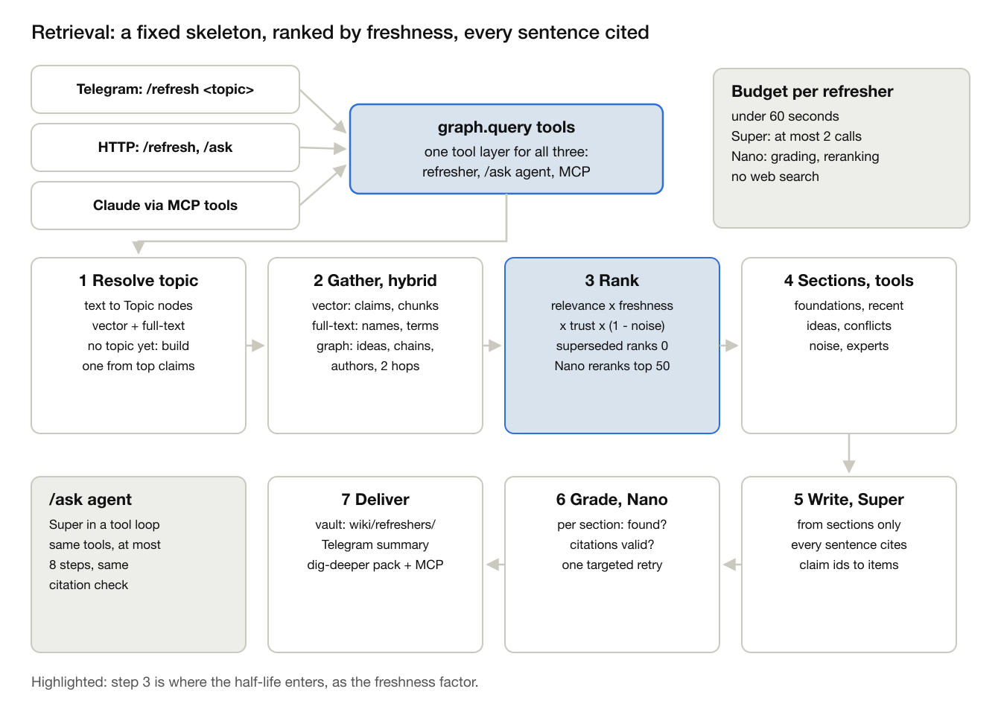
retrieval · fixed skeleton, ranked by freshness, every sentence cited

Entry points
- /refresh <topic> in Telegram or over HTTP: the refresher, the main product.
- /ask <question>: a short cited answer from an agent over the same tools.
- MCP: the read tools exposed unchanged to Claude or any MCP client, for the dig-deeper handoff. No write tools.

Refresher and /ask: what each is for
The refresher is the product. It is topic-shaped: give it a topic and it brings you back up to speed on what you have already collected. Its value is not recollection, which a search already does, but the judgement on top: what is current and what was superseded, what is foundational and what is news, which twelve reposts are one claim, where sources disagree, who to trust on it and why, and a string from every sentence back to the original. You use it before a meeting, a piece of writing or a decision.
/ask is question-shaped: give it a question and it follows the graph wherever the question leads, across topics, through people, claims and ideas. For example:
- Who among the people I follow changed their mind on RAG versus agents this year? Person, then their claims, then SUPERSEDES edges.
- Does the Nebius newsletter on serverless jobs contradict last week's Telegram post? Two claims and the relation between them.
- What connects my notes on knowledge graphs and on coding agents? Shared people, ideas and sources.
 | Refresher | /ask
Input | a topic | a question
Shape | fixed seven steps, the same sections every time | an agent loop, up to 8 tool calls
Scope | one topic | crosses topics
Output | a note in the vault and a Telegram summary | a short cited answer in the chat
Cost | at most 2 Super calls, under 60 seconds | up to 8 calls, varies per question
Evaluated by | sections against the seed labels | spot checks on planted questions
Owner | Kirill | Kirill, stretch
MCP is the third read path: Claude, connected to the same tools, does what /ask does with a stronger model. That is why /ask is the stretch: if time runs out, cross-topic questions still work through Claude.

The refresher, step by step
A fixed skeleton: predictable sections that can be evaluated. The open-ended agent lives in /ask, not in the refresher.
1. Resolve the topic. Embed the text and search Topic titles and Idea summaries with the vector and full-text indexes; Nano picks the match, or the bot asks to choose between two. If the review job has not clustered the topic yet, the top 30 matching claims form an ad-hoc topic.
2. Gather, hybrid. The Neo4j vector index over Claim and Chunk embeddings (top 100); the Neo4j full-text index for names, products and terms that embeddings miss (top 50); and graph expansion up to two hops: claims of the same ideas, supersession chains, the authors. A pool of about 200 claims.
3. Rank. Score = relevance × freshness × trust × (1 − noise). Freshness is the half-life function at query time; trust comes from the Person and Source. Superseded claims score 0 but stay in their chain; a duplicate cluster collapses to its earliest independent source with a count. No reranker is hosted, so Nano grades the top 50 for relevance on a 0 to 3 scale.
4. Build sections. Six structured tools, each a Cypher query plus ranking, fill foundations, recent developments, ideas, conflicts, collapsed noise and experts.
5. Write. Super writes from the sections only. Every sentence cites claim ids, which resolve to items and URLs.
6. Grade. Nano checks each section: is a foundation found, are conflicts flagged, does every citation exist and support its sentence. A failed check triggers one targeted re-gather for that section; after that the section is marked thin rather than padded.
7. Deliver. The refresher note goes to wiki/refreshers/<topic>-<date>.md, linked from the topic hub; the bot sends a short summary with the link; the dig-deeper pack holds a markdown handoff with the claim ids and the MCP endpoint, so Claude can pull strings.
Budget per refresher: under 60 seconds, at most 2 Super calls and no web search; Nano for grading and reranking.

Tools
Tool | Returns | Used by
resolve_topic(text) | topic ids, or an ad-hoc topic | refresher, /ask
search_claims(query, k, since) | ranked claims with score parts | all
get_foundations(topic) | foundation and reference claims, high trust, most confirmed | refresher
get_recent(topic, since) | news and announcements inside their half-life, by event time | refresher
get_ideas(topic) | ideas with claim counts and strings to items | refresher, MCP
get_conflicts(topic) | open CONTRADICTS pairs and SUPERSEDES chains | refresher, MCP
get_noise(topic) | duplicate clusters with counts and the original | refresher
get_experts(topic) | people with EXPERT_IN, trust and rationale | refresher, MCP
get_item(id), get_chain(claim) | a raw item with its sections; a supersession chain | MCP, /ask

/ask and MCP
/ask runs Super in a tool-calling loop over the same tools, at most 8 steps, with the same citation check, and answers in a few paragraphs. MCP exposes the read tools as they are; Claude decides what to pull. /ask is Kirill's stretch after the refresher; MCP belongs to the open workstream. Both reuse the refresher's tools, so they add no new retrieval logic.

How we know it works
- Seed topics in the manifest carry the expected sections: the foundation, the current claim, the superseded one, the duplicate count, the experts.
- Metrics: foundation recall; superseded shown as current, which must be 0; duplicate collapse accuracy; citation validity, which must be 100%; expert precision; latency and cost per refresher.
- Baselines side by side: naive RAG (top-k chunks plus Super) and llm-wiki-agent on the same corpus.

Retrieval plan
Kirill owns the refresher, R1 to R5, and squeezes in /ask (R6) as a stretch; MCP (R7) belongs to the open workstream. Kirill is away 21 to 23 October, so R1 lands before the trip and the rest after it. Dates follow the gates: day 10 (25 October) a refresher cites ideas and people; day 13 (28 October) the eval table is in.
Milestone | By | Done when | Depends on
R1 Contract | 20 Oct | tool signatures and the Refresher schema in refresher/schemas.py; five seed topics with expected sections | Olga: seed topics
R2 Baseline | 24 Oct | /refresh returns ranked, cited claims from vector and full-text search, no sections, no Super; naive RAG baseline recorded | Victor: graph.query basics and vector index
R3 Sections | 25 Oct | six tools, ranking with freshness and trust, noise collapse, Super writes, Nano grades | Victor: review job clusters and trust
R4 Handoff | 26 Oct | refresher note in the vault, Telegram summary, dig-deeper markdown pack
R5 Eval | 27 Oct | eval table against naive RAG and llm-wiki-agent; latency and cost measured | Olga: seed labels
R6 /ask, stretch | 28 Oct | /ask loop over the section tools with the same citation check; the first thing dropped if R1 to R5 slip | R3 section tools
R7 MCP | 27 Oct | MCP endpoint over the section tools (open owner) | Kirill: section tools by 25 Oct
Freeze | 28 Oct | fixes only from here

Seed corpus and test fixtures
Seed documents go through the same front door as real ones. Keep the originals as received and let the file importer (channels/importer.py) turn them into RawItems, so the seed exercises every stage after the channel. Do not hand-write raw/ items: they would skip the code we most need to test.
- eval/seed_corpus/originals/: the files as received. Telegram Desktop copy-pastes and LinkedIn pastes as .md, .eml for emails and newsletters, .html or a URL for articles, .pdf, .png, .ogg voice notes, a .txt with a YouTube URL.
- eval/seed_corpus/manifest.yaml: one entry per file with the channel to simulate, who forwarded it and when, and the expected labels: author, people, kind, durability class, rough claim count, and relations to other seed items (duplicate of, supersedes, contradicts).
- refresher import eval/seed_corpus/ runs the importer and the full pipeline into a fresh vault and graph.
Fixtures per level, so each owner can test without waiting for the others:
Level | Fixture | What it tests | Owner
Channel | recorded Telegram updates and .eml files | adapter output equals the expected RawItem | Olga (Telegram), Kirill (email)
Parse | originals to stored Documents | sections, provenance, LinkedIn and YouTube metadata | Olga
Extract | Document to Extraction, one golden file per seed item | author, people, claim count, kinds, durability; scored, not exact-matched | Olga
Graph | frozen Extraction records, no LLM calls | placement, relation edges, merges, topics; deterministic and cheap | Victor
End to end | manifest labels | duplicates collapsed, supersessions found, refresher sections filled | Olga with Kirill
Planted cases: an original, a repost from another channel and a later correction, sent in reverse order; one author under two handles (Telegram and LinkedIn); a multi-layered article; a newsletter digest that must split; a LinkedIn article; a voice note; a YouTube video without captions; an email with a PDF attachment.
Status on 19 October: six seeds import cleanly. Three are Telegram copies of an AI assistant's answers, one of them a near-duplicate of another sent 8 seconds later; one is an event agenda; one is a Russian channel repost; one is a LinkedIn Pulse article. uv run refresher-import eval/seed_corpus writes raw/*.json, --check fails when raw/ is stale, and uv run pytest covers the parsers and the corpus. The Telegram header names who sent the message, which goes to forwarded_by, not author_hint: the AI answers carry author "AI assistant", so the people they list become mentions, not authors.
Growing it: every real ingest already leaves a RawItem in raw/. refresher seed add <item_id> copies one into the seed with labels, so the corpus grows from real use.

Verified platform facts
Checked 15 October 2026 against the Token Factory model catalog and Nebius Serverless AI docs. Regions differ per model, so each tier gets its own base URL in config.
Need | Choice | Note
Fast calls: classify, extract, relate, grade | nvidia/NVIDIA-Nemotron-3-Nano-30B-A3B, eu-north1, 262K context | Alternative in the same region: nvidia/Nemotron-3_5-Lightning, 1024K
Reasoning: refresher synthesis, conflict adjudication, people profiling | nvidia/nemotron-3-super-120b-a12b, us-central1, 256K | Ultra (550B) exists; likely unnecessary
Embeddings | Qwen/Qwen3-Embedding-8B, eu-north1 | The only embedding model hosted; the rules need at least one NVIDIA model, which Nano and Super satisfy
Reranker | None hosted | Nano acts as grader
Images and scanned PDF pages | nvidia/Nemotron-3.5-Super-VL, us-north1 | Checked 18 October 2026
Speech: voice notes, YouTube without captions | nvidia/parakeet-tdt-0.6b-v3, run by us: CPU on the endpoint for short notes, GPU Serverless Job for long audio | Token Factory hosts no speech model. CC BY 4.0, 25 European languages including Russian and Ukrainian; checked 18 October 2026
Graph database | Neo4j Aura Free for the demo, Neo4j 5 in Docker for development and tests, with native vector indexes | Limits and auto-pause to check on day 1
API | OpenAI-compatible at api.tokenfactory.nebius.com/v1; langchain-nebius offers ChatNebius with tool calling and structured output | A third-party report needed a us-central1 host for US models. Verify both tiers on day 1
Serving | Serverless AI Endpoint on a CPU platform | nebius ai create --type endpoint with image, container port, env and env-secret; managed HTTPS URL
Background work | Serverless AI Job | nebius ai create --type job; REST POST to api.nebius.cloud/ai/v1/jobs; no built-in scheduler found, so the endpoint triggers it
Web research | Tavily search with topic and time_range, and extract | Credits through the Nebius Builders Program
Chat front | Own Telegram bot with aiogram; email through a dedicated inbox over IMAP | Commands: /refresh <topic>, /ask <question>
Credits | Devpost activation code NEBIUS-DEVPOST-GLOBAL26 for $25 Token Factory; Builders Program adds Token Factory and Tavily credits | Devpost resources page

Team split
Three owners and one open workstream. Kirill owns the architecture and the schemas, email ingestion and the knowledge half-life, Olga owns ingestion, Victor owns the graphs, the Miro visualization and the people profiles. Kirill also owns the refresher, with /ask as a stretch. The MCP endpoint and the platform work have no owner yet and are decided at the next sync. Availability from the chat: Kirill works this weekend and Monday, travels three days mid next week, full time from the end of next week; Olga starts Monday 19 October at half days; Victor to confirm.
Owner | Workstream | Deliverables | Hands off to
Olga | Ingestion: channel adapters (Telegram bot now, mobile app later) and content parsers for articles, LinkedIn shares, YouTube, voice notes, PDFs and images; claim and entity extraction into the Extraction record; file importer, seed corpus and eval | channels/telegram.py, engine/parse/ (web, linkedin, youtube, pdf, image, audio), engine/extract.py, channels/importer.py, eval/seed_corpus/, eval/test_relate.py | Kirill: seed corpus by day 4 so scoring has real data. Victor: Person stubs with enrichment_status from ingest
Kirill | Architecture and schemas: ARCHITECTURE.md, pydantic schemas including RawItem and the node and edge enums. Email ingestion and knowledge half-life: dedicated inbox polled over IMAP, forwards and mailing-list subscriptions, durability classes, freshness, confirmation reset. Refresher: resolve, gather, rank, sections, write, grade, deliver, and its eval. /ask as a stretch | ARCHITECTURE.md, refresher/schemas.py, channels/email.py, engine/scoring.py with unit tests, retrieval/ (resolve, gather, rank, sections, write, grade), ask/ (stretch) | Olga and Victor: schemas, RawItem, Extraction and graph enums by day 2. MCP owner: the section tools by 25 October
Victor | Graphs, Miro visualization, people profiles: Neo4j graph module that ingest calls (graph.apply), placement and relation check, Tavily enrichment, trust, graph tests on frozen Extraction records | graph/ (store.py on Neo4j, apply.py, relate.py, review.py, query.py), engine/people.py, viz/miro.py | Olga: graph.apply stub by day 3, real placement by day 5. Kirill: graph.query functions by day 7
Open | MCP and platform: MCP endpoint over the refresher's tools, Dockerfile, Serverless Endpoint and Job, demo page, video | mcp/, deploy/, api/app.py, video | Owner decided at the next sync
Interfaces that must be agreed on day 1 and not changed after:
- The pydantic schemas in refresher/schemas.py. Everyone builds against them.
- The vault layout: raw/, wiki/ideas, wiki/people, wiki/sources, wiki/topics, wiki/refreshers, index.md, log.md. Frontmatter keys fixed in store/vault.py.
- The HTTP contract: /ingest takes an item, /refresh takes a topic, /feedback takes a claim or person id and a vote, /health returns model ids and last consolidation time.
- The RawItem schema that every ingestion channel produces, Telegram, email or a future mobile app, in refresher/schemas.py (landed 19 October): channel, source_id, source_name, author_hint (who wrote it: name, handle, email, url), forwarded_by (who shared it with us, same fields), captured_at, published_at, url, kind (input shape for routing: text, link, file, image, voice, video), text, attachments (mime, path), schema_version. Unknown fields are rejected and timestamps must carry a timezone. content_hash is derived from the text and url for exact-duplicate checks; near-duplicates are the relation check's job.
- The Extraction record, ingestion's processed/<item_id>.json: source (the RawItem fields), sections, links, claims (claim_id, statement, kind, durability_class, half_life_days, confidence, evidence spans), entities (person, organization, concept), triage, reviews and quality_gate_passed. refresher/schemas.py reads it and ignores fields it does not use, so ingestion can add fields without breaking the graph or KM.
- The graph module API (graph.apply, graph.review, graph.query) and the Extraction record it takes; node and edge types in refresher/schemas.py. Ingest calls apply, the review job calls review, retrieval and the Miro export read through query.
Shared across the team: README feedback section, filled whenever anyone hits a platform issue. Daily 15-minute sync in the chat; a call this weekend to confirm the split.

Timeline
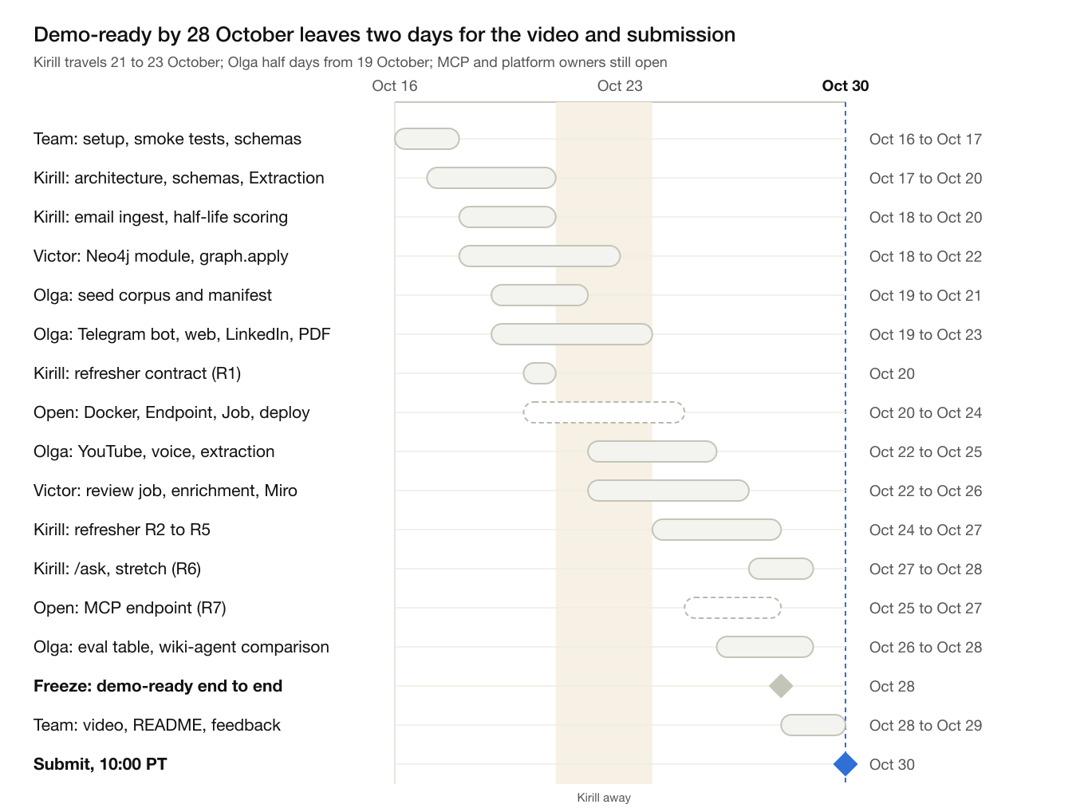
timeline · 16 to 30 October 2026, one row per workstream
Four lanes run in parallel, Kirill, Olga, Victor and the open MCP and platform work, and meet at the freeze on 28 October. Kirill's schemas, email ingest, scoring and the refresher contract land before his trip on 21 to 23 October; the refresher is built from 24 October. Done looks like this at each gate: day 1, Nano and Super answer structured calls and the schemas are agreed; day 5, a forwarded message lands in the deployed vault with a relation edge; day 10, a refresher cites ideas and people; day 13, the eval table and README are in; day 15, the video is public and the Devpost form is submitted.

Demo script and submission checklist
The video must show triage, people and strings, not just organised notes, or it looks like the wiki pattern with timestamps. Under three minutes.
- Forward three Telegram messages on one topic: an original announcement, a repost from another channel, and a later correction. Show the bot replies: filed under, by whom, duplicate of, supersedes.
- Open the vault in Obsidian. Show the raw items, the idea note with its string back to them, and the graph view.
- Run /refresh on the topic. Show the refresher: ideas, current versus foundation, collapsed noise with a count, conflicts.
- Show the experts graph: three people, their domains, trust with rationale, one enriched from Tavily.
- Open the dig-deeper pack in Claude and ask one follow-up that pulls a string through MCP.

Submission
Submission, all due before Friday 30 October 2026, 10:00 PT:
- ☐ Public repository with Apache-2.0 license visible at the top of the page
- ☐ README with setup, run instructions, how Nemotron, Token Factory, Serverless and Tavily are used
- ☐ Working demo URL: the Serverless Endpoint with /health and the read-only experts graph page
- ☐ YouTube video, public, under three minutes, no third-party music
- ☐ Project description: what, why, how it works
- ☐ Track: Personal AI
- ☐ Feedback on Token Factory, AI Cloud and NVIDIA models
- ☐ City selected if anyone attended a Builders and Brews event
- ☐ English for all materials

Risks and fallbacks
Risk | Fallback
Nemotron structured output or tool calling is flaky through Token Factory | JSON-mode prompting with pydantic validation and one retry; keep any non-NVIDIA fallback out of the demo
Cross-region errors between Nano in the EU and Super in the US | One base URL per tier in config; verify on day 1
People enrichment is wrong or feels intrusive | Only public professional fields for authors of channels, newsletters and articles; never enrich private individuals from personal chats; sources shown; person notes editable
Scanned PDFs and images need the US-region vision model | Text layer first; Super VL only for pages without text; on failure keep the raw file and skip it
YouTube blocks caption fetches from cloud IPs | Download the audio and transcribe with Parakeet; the user can also forward the transcript as text
LinkedIn posts sit behind the login wall, and LinkedIn may block cloud IPs | Public articles via JSON-LD; posts via Tavily extract; otherwise the user forwards the post text or a screenshot. No logged-in scraping
Neo4j Aura Free pauses or hits its limits | Neo4j in Docker on a Nebius VM; rebuild from the vault and Extraction records
Serverless Endpoint disk is ephemeral | Vault in a git repository pushed after each write, or Nebius object storage; the graph rebuilds from the vault and the stored Extraction records
Judges read it as Karpathy's wiki with timestamps | The side-by-side eval on the seed corpus and a demo that shows dedup, supersession, people and strings
Graph quality: the Qdrant and Neo4j warning from the chat | Typed edges, few of them, each with rationale; accept unrelated generously; show precision over recall
Olga's extractor calls Backboard with gpt-4o-mini, not Nebius Token Factory | Point engine/llm.py at Token Factory with Nemotron Nano before the freeze; the hackathon judges the use of Nebius and NVIDIA models
Credits run out | Nano for every ingest call; Super only for refreshers and profiles; Tavily budget of 3 searches per person

